## Introduction

In this project you will have to create a **filesystem explorer** that allows the **user** to **navigate**, **create directories** and **upload files.** The file explorer is a **tool** that allows you to directly **view and manipulate the files and directories** associated with a **path**, so you must take into account from which **path** the user starts and which path they can access.

In the following image you can see an **example** that can serve as a reference (you won’t have to implement all the functionalities shown in the image):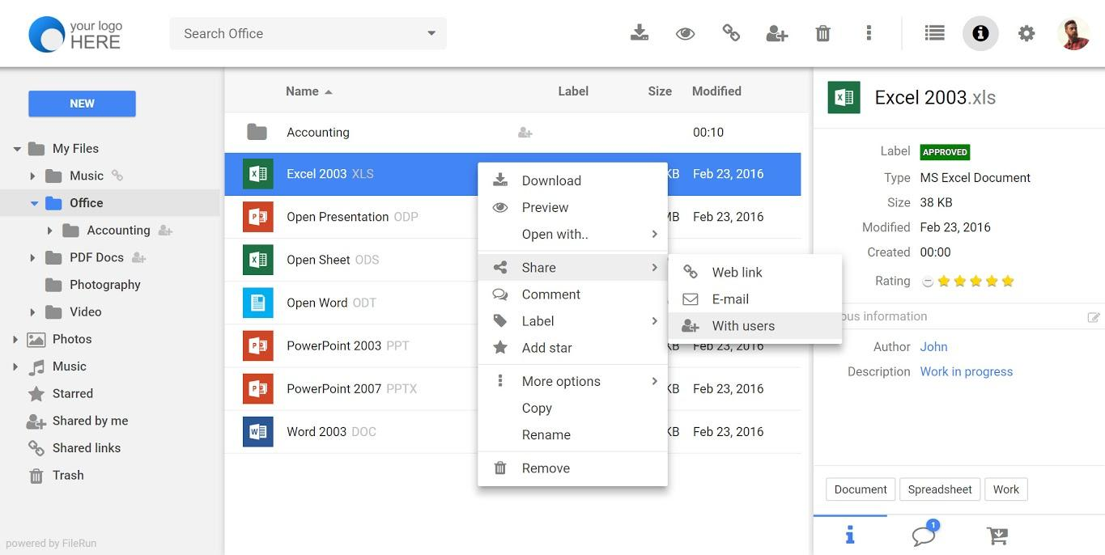

## What are the main objectives in this project?

* Understand how the **file system works**
* Improve your knowledge in **PHP**
* Improve your knowledge in **HTML**, **CSS** & **Javascript**
* Improve your knowledge in **logic** and **programming**

## 1. General analysis

First of all, you will have to **analyze the project requirements** so you can get an idea of the **project objectives**, then **design the structure** of the application and analyze the **actions** that the user can do so you have a clear idea about which are the **key points** and what the **user interface** will be like .

### Step 1: Analyze the project requirements

In the first step you must **analyze** the **requirements** that the **project must meet** and what **actions** the **user** can do.

* **Create**, **modify** and **delete directories**
* **Browse through directories** from an **initial path**
  + The **initial path** will start from a **folder** inside the **project repository** whose name will be "**root**".
* **Search directories** and **files** by **name**
  + In the case of **searching** for **files by name**, you must also be able to specify **their extension** **as part of the name**.
* **Navigate through the initial path** established and all the folders created from that path. Therefore the **user will not be able** to see or **navigate** to the **parent folders of the “root” folder**.
* **Upload a** **file** to a directory
* **See** the following **information** of **files** and **directories**
  + Creation date
  + Last Modified Date
  + Extension (if it’s a file)
  + Size
    - If it is less than **1 MB** show **KB**, otherwise show **MB**
* **Show** the **icon** of the main **file extensions** such as:
  + doc
  + csv
  + jpg
  + png
  + txt
  + ppt
  + odt
  + pdf
  + zip
  + rar
  + exe
  + svg
  + mp3
  + mp4
* **View** the uploaded **images**.
* **Play** the uploaded **videos**.
* **Play** the uploaded **audios**.

### 

### 

### Step 2: Design the project structure

**Before** starting to **develop the project** you should take into account and **analyze** the following points:

* How will the **interface** be
  + You will have to **design a wireframe** of your application taking into account the requirements.
* What **actions** can be executed by the user
  + You will have to **design a use case diagram**
* **Analyze** and **understand** what brings more value to the user
* **Analyze** how you will organize the project at the level of **directories** and **files**

### Step 3: Start to develop the project

Once you have all the **designs** and **organization** of your **project** raised, you must **start developing it**.

### Step 4: Extra functionalities

In addition to the **requirements** mentioned above, you can add the following **extra functionalities** so that the **user is able to**:

* **Show the information** of the uploaded **“.csv”** files on the screen.
* **Move files** and **directories between folders**
* When **deleting** a **file** or **folder**, it will be moved to a **specific folder** called "**trash**", so if you want to **delete it completely** you must delete it from the mentioned folder.

## 2. Project organization

Next you will have to create a document where you can explain in detail how the current project is organized. It is important that it be updated throughout the life of the project. A PDF version is required within the project folder for the project documentation.

The document must include at least:

* Requirements documentation
* Wireframes
* Use case diagram
* Record of incidents that were detected during project execution
* Record of lessons learned

## 3. Development

Develop the **file system explorer** taking into account its **architecture** and respecting the **frontend** and **backend layers**. It is important that you keep in mind that the **organization** is very important as well as the **documentation** you provide to the project.

## 4. Requirements

* You **will not be able** to use the $GLOBALS **variable**.
* You must use **GIT**
* You must use the **PHP > v8**
* Create a **clear** and **ordered directory structure**
* Both the **code** and the **comments** must be written in **English**
* Use the **camelCase** code style to define variables and functions
* When using **HTML**, **never** use **inline styles**
* Remember that it is important to **divide the tasks into several sub-tasks** so that you can associate each particular step of the construction with a **specific commit**
* You should try as much as possible that the **commits** and the **planned tasks** are the same
* **Delete files and comments** that are not used or are not necessary

## 5. Deliverables

You will need to deliver the following:

* Forked repository with code: <https://github.com/assembler-institute/filesystem-explorer>
* You must create a correct documented README file in the root directory of the project (see guidelines in **Resources**).
  + In addition, you will have to add the following sections in the readme file:
    - Comparison of the original design (Wireframe) with the final result of the project
    - Comparison of the use case diagram with the actions that the user can finally perform
    - How you have organized and distributed the tasks

## 6. Resources

* File system:<https://es.wikipedia.org/wiki/Administrador_de_archivos>
* PHP FileSystem W3C:<https://www.w3schools.com/php/php_ref_filesystem.asp>
* PHP FileSystem [Oficial]:<https://www.php.net/manual/es/book.filesystem.php>
* README Guidelines Example:<https://gist.github.com/PurpleBooth/109311bb0361f32d87a2>
* File Creation & Modification Date: <https://fuelingphp.com/get-file-date-php/>

### 6.1. Wireframes web tools

* Moqups: <https://app.moqups.com/>
* Draw.io: <https://app.diagrams.net/>
* Cacoo: <https://cacoo.com/es/>